
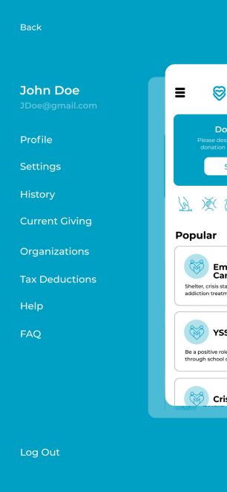
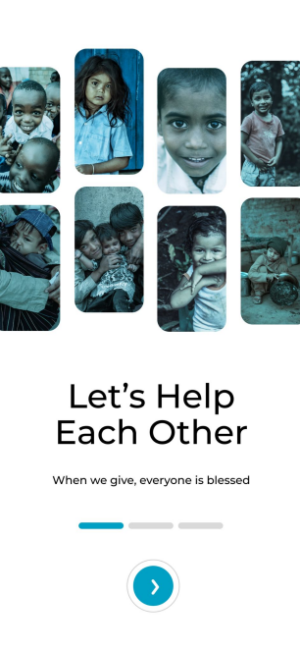

GIVING APP A RICH STORYTELLING DONATION AND GIVING PLATFORM
Pitch Deck - DRAFT
© 2024 Shift Interactive - Confidential and Proprietary Information
MRR


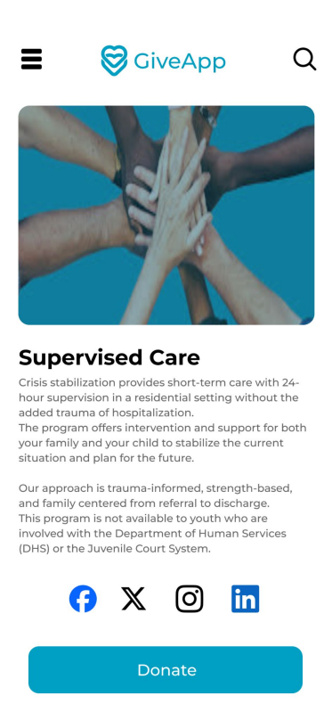

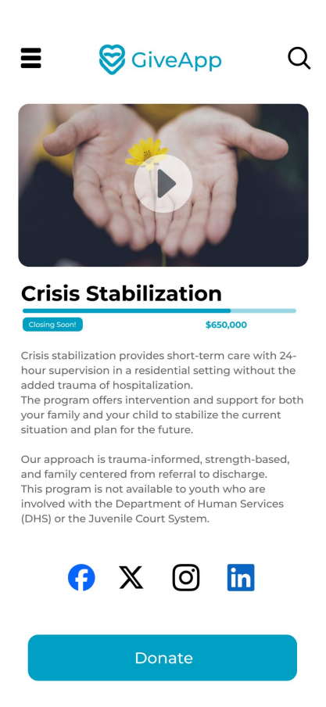
Empower those
who help others
With the Shift Giving App, donors can make an impact through direct giving or
through ongoing giving via payroll deductions. And nonprofits can offer an easy
giving platform and connect with new donors through an engaging and
meaningful storytelling experience!
© 2024 Shift Interactive - Confidential and Proprietary Information
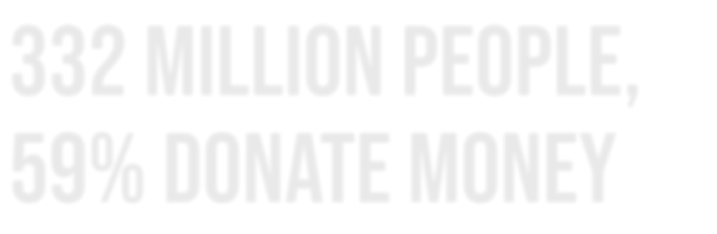
332 Million PEOPLE, 59% DONATE MONEY
Why Increase Engagement?
● 55% of people who engage with nonprofits on
social media take some sort of action.
● 59% of those people donate money.
● 53% volunteer.
● 43% attend or participate in charitable events in
their community because of social media.
● 46.1% of churches say Social Media is their most
effective method of Outreach.
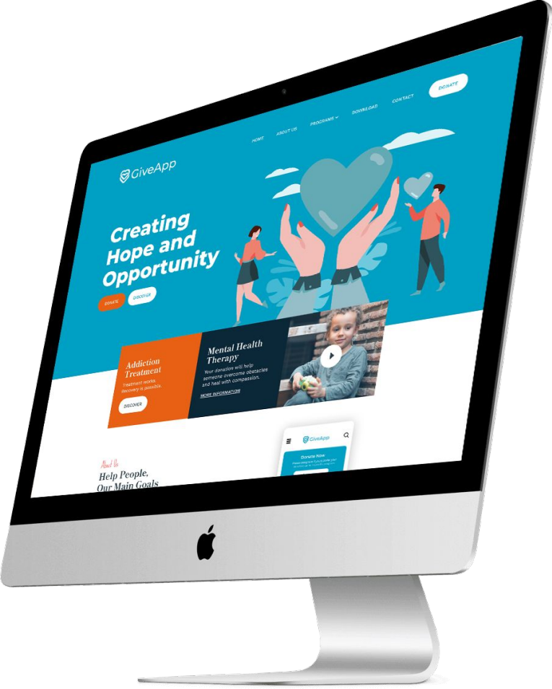© 2024 Shift Interactive - Confidential and Proprietary Information 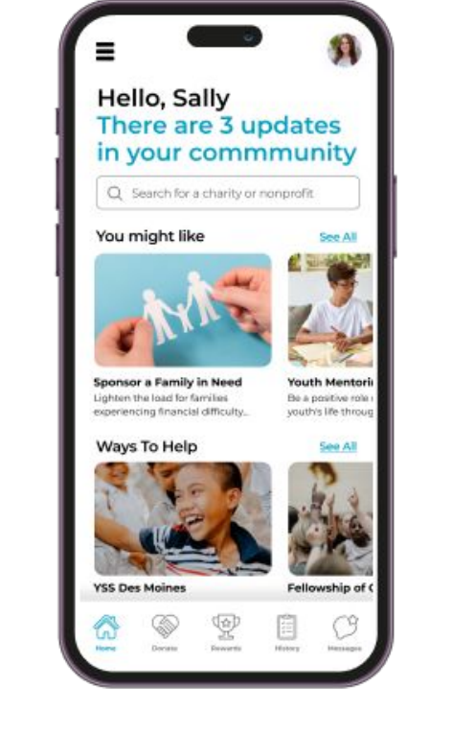
GIVING PLATFORMS TODAY
Lack of Engagement Limited Functionality All Different Apps
High Fees

Money is given and very little feedback or direct engagement is returned to the donor.
Most platforms are mobile responsive websites that are a funnel to process funds. Major platforms focus on corporate giving and volunteering.
Multiple applications for multiple organizations to keep track of.
Current giving platforms have high fees or take large investments to build out, leaving smaller organizations out of the market.
© 2024 Shift Interactive - Confidential and Proprietary Information
Problem Slide 2?
issues we solve
GIVING CAN BE EASIER
01 02 03 04
Donor receipting/gift
acknowledgement
Ongoing communications and engagement with donors - impact stories drive action
Data analytics around giving
Giving donors an overall picture of their giving and the impact it’s
making
© 2024 Shift Interactive - Confidential and Proprietary Information
GivingApp
Seamless SIMPLE For Donors
01 02
Multi-Tenancy on one platform, ability to suggest organizations
See the direct impact of your giving with push notifications
05 06
Open to small organizations, animal rescue, humanitarian relief, sports clubs, churches, etc
Focused impact stories drive engagement around donor concerns
03 04
Variety of payment methods, manage recurring transactions
Easily track all tax-deductions and any charitable contributions
₀₇ The ability to give to any active organization registered as
501(c)(3)
© 2024 Shift Interactive - Confidential and Proprietary Information
Seamless SIMPLE For Non-Profits
01
02 03
04
Rich storytelling capabilities for organizations, a media library with ability for uploads from field staff
Drive engagement and
transparency with impact stories via push notifications
Gift acknowledgment and
tax-deduction messaging platform
Easy to sign up and personalize for your organization, one code or QR to send out to donors. Social sharing embedded in posts.
05 06
07 08
Low tiered scaled fees, helping organizations that may not be able to afford an app or platform
The GivingApp is a non-profit entity created for non-profit entities. Registered 501(c)(3) only
Netflix like recommendations via email to donors for similar non-profit entities
Excellent for Fund-a-need
campaigns
GivingApp
© 2024 Shift Interactive - Confidential and Proprietary Information
© 2024 Shift Interactive - Confidential and Proprietary Information
GivingApp Demo
© 2024 Shift Interactive - Confidential and Proprietary Information
GivingApp Demo
GivingApp Demo
Multi-TenancY
© 2024 Shift Interactive - Confidential and Proprietary Information
TRACK
YOUR
GIVING
With the Shift Giving app, we make it easy for you
to track your giving. Quickly scan receipts and
upload.
© 2024 Shift Interactive - Confidential and Proprietary Information
Dashboard
Future Platform for data analytics around giving (by cause, geography, demographics, etc.)
© 2024 Shift Interactive - Confidential and Proprietary Information
Communication TOOLs
Schedule donor receipting & gift acknowledgement
© 2024 Shift Interactive - Confidential and Proprietary Information
FULL MESSAGING CAPABILITY
© 2024 Shift Interactive - Confidential and Proprietary Information
FULL MESSAGING CAPABILITY
© 2024 Shift Interactive - Confidential and Proprietary Information
Payroll Deduction Integration With Affiliate PEO’s FUTURE OPTION - Workplace Giving
© 2024 Shift Interactive - Confidential and Proprietary Information
PHASESMVP to beta users
Push Notifications
On-Demand Messaging System User Sign Up/Delete
Payment System
Reporting
Simple Campaigns
ACH Funds To Orgs
Thank You Emails
Multi-Tenancy
full app release
501 (C) (3) Status?
Media Library
Apple/Google Pay
Org Online Sign Up
Recurring Donations
Advanced Giving Campaigns Dashboard
Taxable Donations Tracking User/App Uploads - Media Library
phase 2
Payroll Deduction
Advanced Billing
Features/Analytics
Multi-Currency Languages Recommendation Engine Gamification
Grant Tracking
Event/Gala Ticketing Auction
© 2024 Shift Interactive - Confidential and Proprietary Information
Go-To Market
Go-To Market
⁰¹ Nonprofit Recruitment
While development is happening, Andy and Justyn will meet with potential nonprofits walking them through a clickable design prototype of the app and securing buy-in before the app is live.
⁰³ Collaborate with other Nonprofits
Whether it be conferences or nonprofit events, the Shift Giving team plans to be at these events sharing what we have planned.
⁰² Digital Marketing & Content Strategy
Work with a marketing firm to define digital marketing strategy including email, PR, targeted ads and
influencer strategy. The marketing website will be developed and rich content (blogs) added to help with SEO.
⁰⁴ Beta Release
We will start with a beta release to roughly 100 super users. The goal will be to get feedback, make
changes, work out bugs before fully going to market. © 2024 Shift Interactive - Confidential and Proprietary Information

